**Vault Install and Setup**

Follow the below steps to install Vault on your Windows system:

1. Go to the following link to download Vault: https://developer.hashicorp.com/vault/downloads

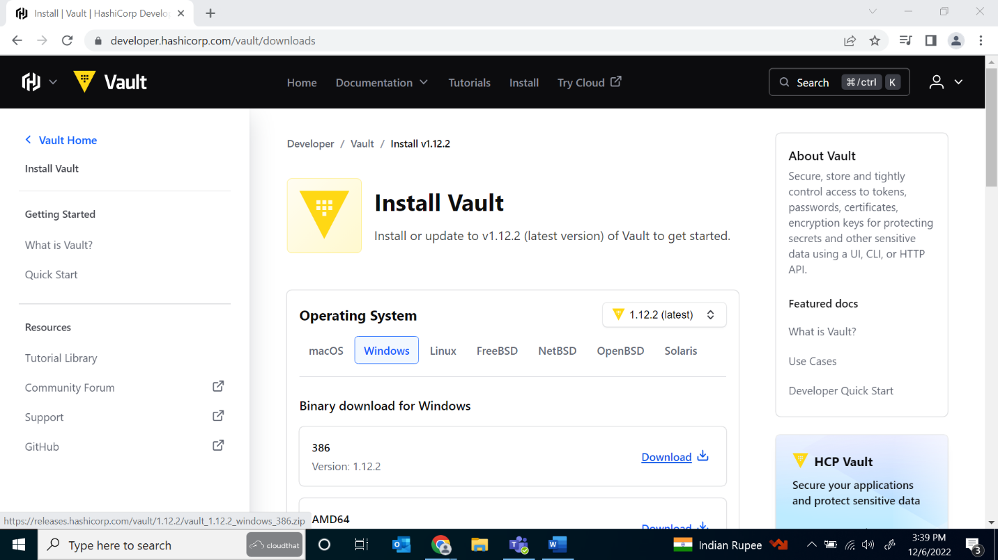

1. Move the installation file to tmp folder (where Terraform is installed) in your C:\\ drive and run it:

1. Open CMD and run the following command to verify that Vault is installed on your system: **vault server -help**

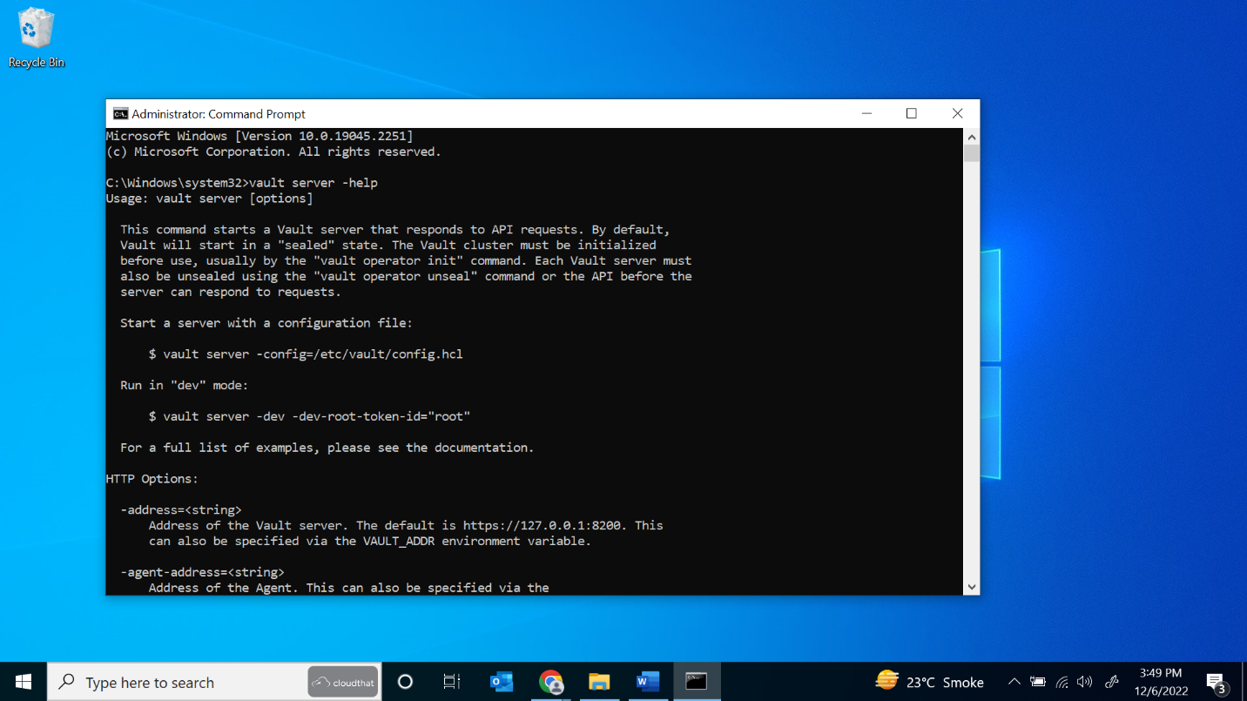

1. Start a Vault server in development mode (dev server) using the following command: **vault server -dev**

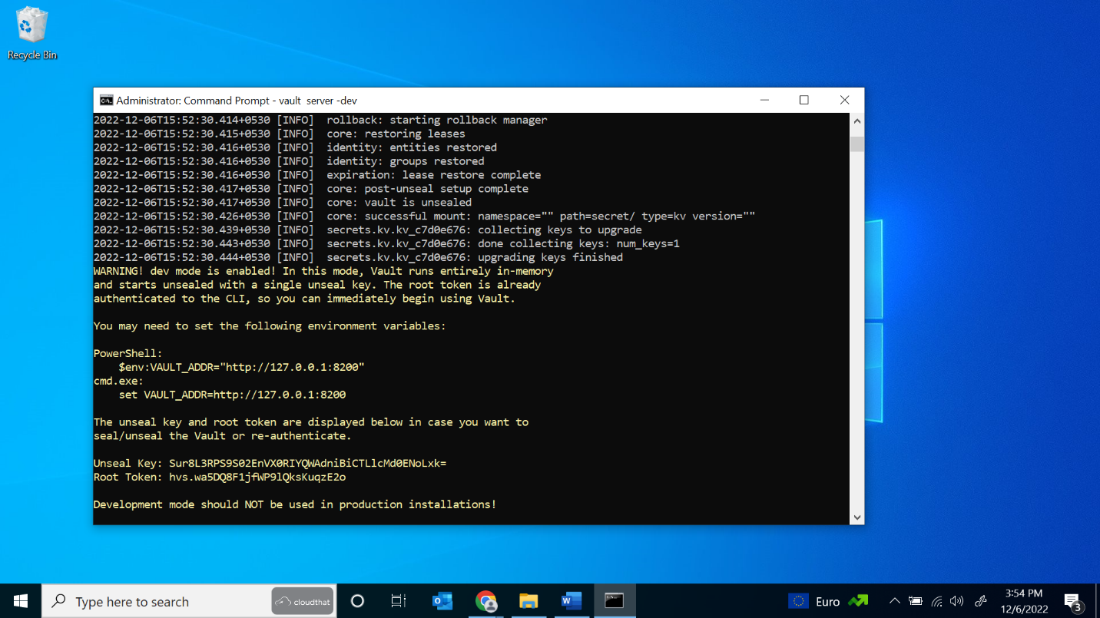

Copy the Unseal key and root token to notepad window for later.

1. Launch a new terminal session and type the following command to configure the Vault client to talk to the dev server: **Set VAULT_ADDR=http://127.0.0.1:8200** (without quotes) and press enter. Do the same for the following command and replace it with your Vault token copied earlier: **Set VAULT_TOKEN=<Your Vault Token>** (without quotes)

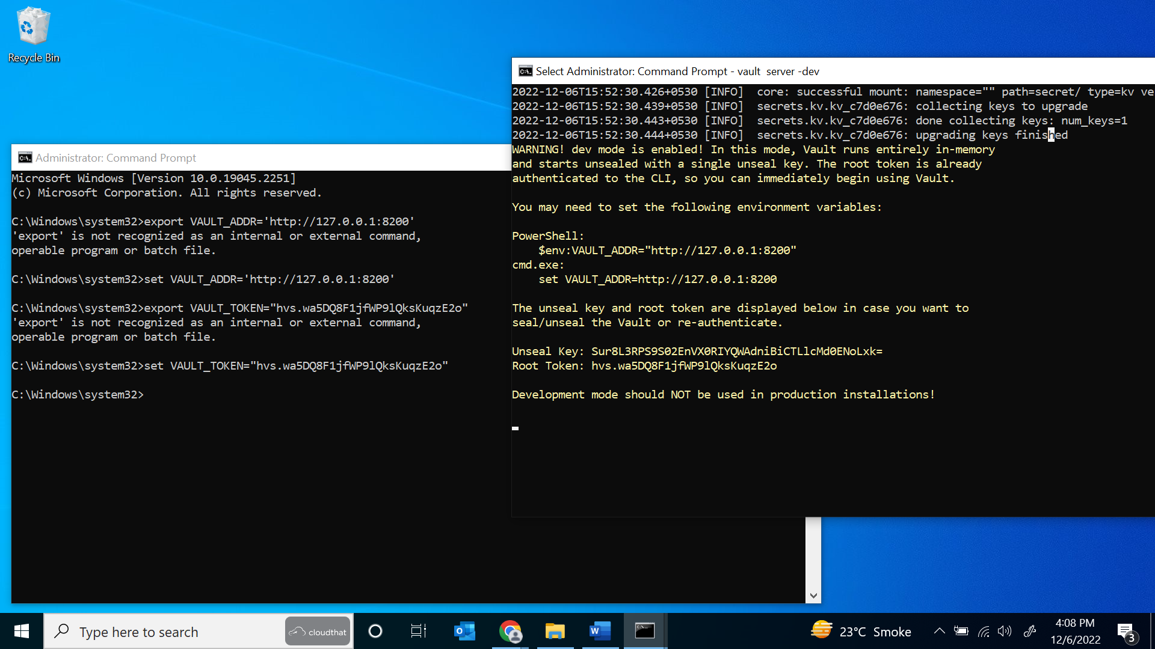

1. Run the following command to verify that your Vault is running: **Vault status**

